Bootcamp with Lina
From £499* per person
Package includes:
- Return flights London to Athens on Wizzair
- All pre-payable airport taxes and charges
- Return airport transfers to/from Hotel
- 3 nights’ accommodation at Pan Hotel (Athens) inclusive of breakfast
- 2 nights’ accommodation at The Ranch, full board (excluding drinks) including parties on Friday and Saturday nights at the Saloon
*Price is subject to exchange rates and availability, accommodation in Athens is based on twin share rooms, at the Ranch based on 4-6 sharing (no twins available)

Itinerary:
Day 1: Fly to Athens (ATH) on Wizzair
Depart London from London Luton Airport
Flight: |  | Departure |  | Arrival
Thurs 9th March 2023 | W94467 | London Luton | 06:45 | Athens | 12:20

Minibus transfer to Hotel
Check in to Hotel at 14:00
Overnight at Hotel
Day 2: Transfer to The Ranch
Breakfast at Hotel
Check out of Hotel by 12:00
Minibus transfer to the Ranch (not included)
Check in to the Ranch
Schedule to follow
Dinner at the Ranch
Overnight at the Ranch

Day 3: Bootcamp
All meals at the Ranch
Schedule to follow
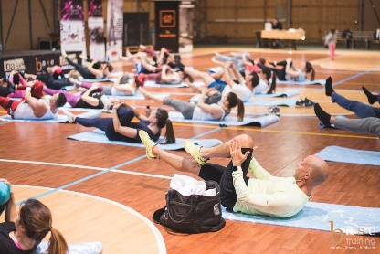
Overnight at the Ranch
Day 4: Transfer to Athens
Breakfast at the Ranch
Check out of the Ranch by 12:00
Minibus transfer back to Athens (not included)
Check in to hotel at 14:00
Day at leisure
Overnight at the Hotel
Day 5: Athens
Breakfast at Hotel
Day at leisure
Overnight stay at hotel
Day 6: Depart for London
Breakfast at hotel
Check out of Hotel
Minibus transfer to Airport
Flight: |  | Departure |  | Arrival
Tues 14th March 2023 | W94468 | Athens | 13:05 | London Luton | 15:10

Arrive in to London Lu

